

**Adama Science and Technology University**

**School of Electrical Engineering and Computing**

**Course Title:** Fundamentals of Electrical Engineering

**Course Number:** PCE2101

**Lab:** Laboratory Experiment No - 2

**Title:**DC circuit Analysis

**Prepared by:**

**Name ID**

**Submitted to:** Tewdros

Date of conduction: November 18, 2016

Date of submission: November 25, 2016

**Acknowledgement**

We would like to acknowledge our lab assistant Tewdros for his support and explanation in the laboratory. Through the group work and experiment we were able to comprehend the topics that were raised and able to communicate with each other well.

**Theoretical Background**

Kirchhoff’s first law is based on the law of conservation of charge, which requires that the algebraic sum of charges within a system cannot change. **Kirchhoff’s current law (KCL)** states that the algebraic sum of currents entering a node (or a closed boundary) is zero.

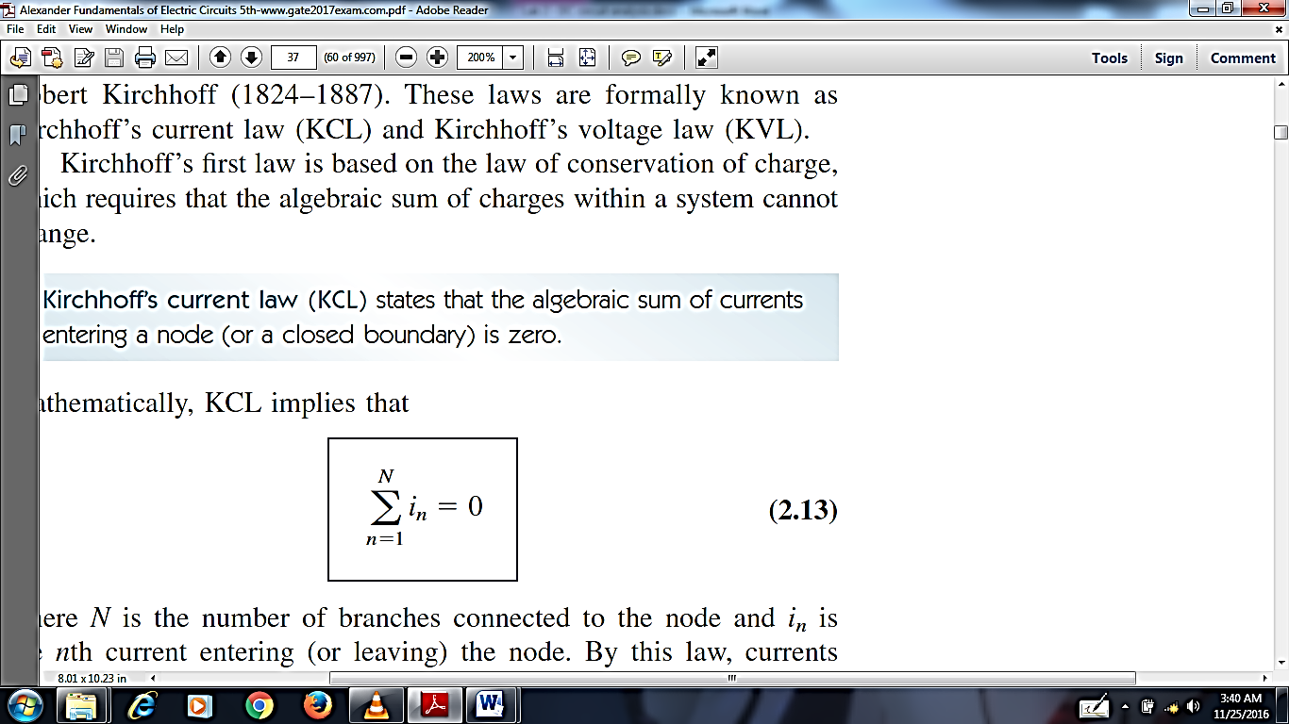

In the above equation *N* is the number of branches connected to the node and *in* is the *n*th current entering (or leaving) the node. By this law, currents entering a node may be regarded as positive, while currents leaving the node may be taken as negative or vice versa. This law indirectly implies that the sum of the currents entering a node is equal to the sum of the currents leaving the node.

Kirchhoff’s second law is based on the principle of conservation of energy.**Kirchhoff’s voltage law (KVL)** states that the algebraic sum of all voltages around a closed path (or loop) is zero.

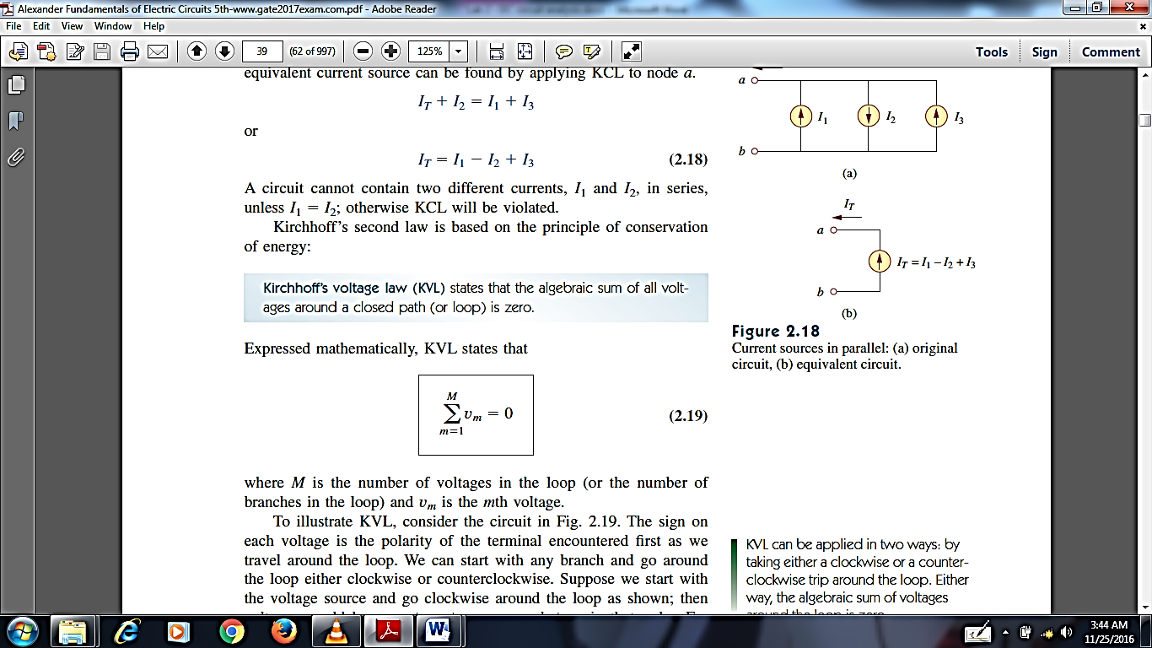

In the above equation Mis the number of voltages in the loop (or the number of branches in the loop) and *vm* is the *mth*voltage. KVL can be applied in two ways: by taking either a clockwise or a counterclockwise trip around the loop. Either way, the algebraic sum of voltages around the loop is zero. KVL indirectly implies that:

Sum of voltage drops = Sum of voltage rises

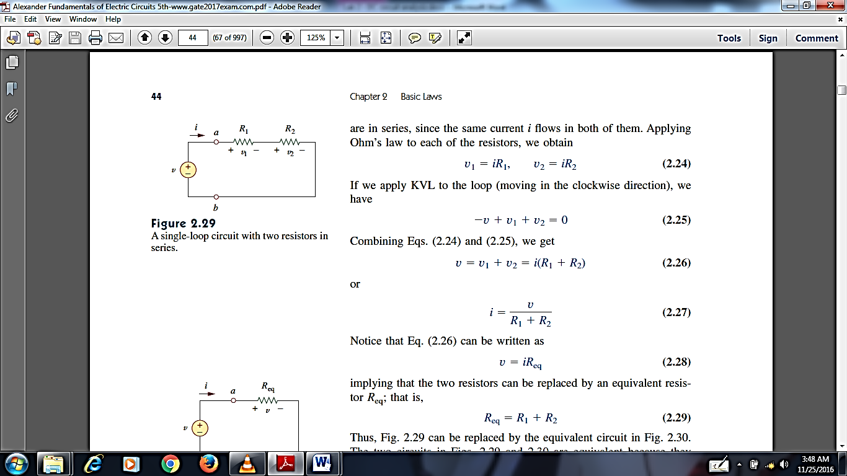

Figure 1: A singe loop with two resistors connected in series

To determine the voltage across each resistor in figure 1, we have the following formula:

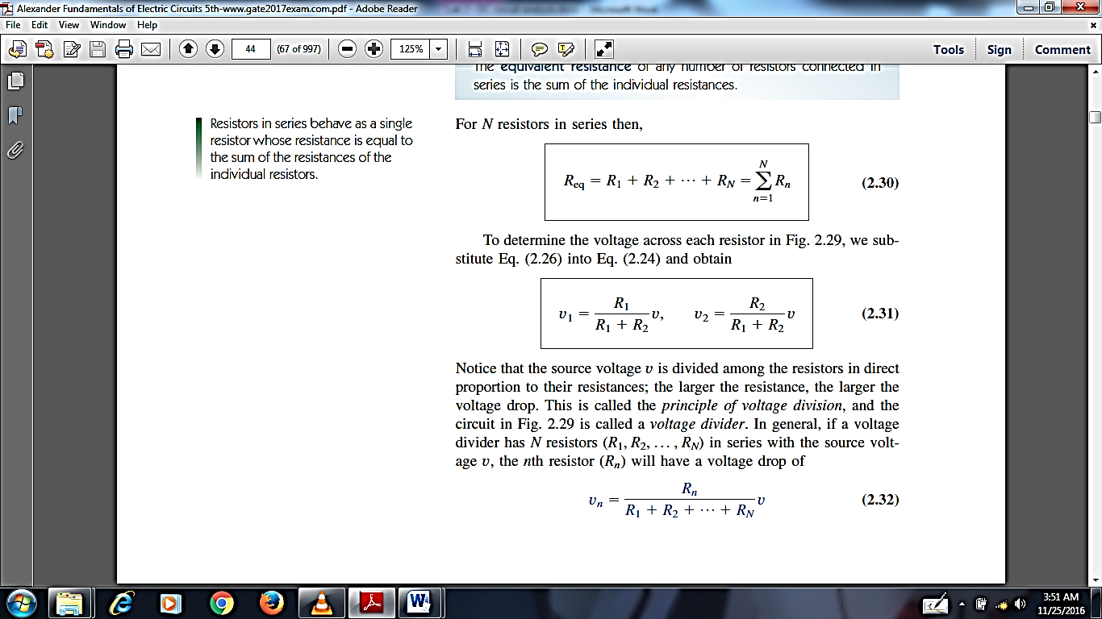

Notice that the source voltage *v* is divided among the resistors in direct proportion to their resistances; the larger the resistance, the larger the voltage drop. This is called the ***principle of voltage division or voltage divider rule (VDR)***, and the circuit in figure 1 is called a ***voltage divider***. In general, if a voltage divider has *N* resistors (R1, R2, R3… RN) in series with the source voltage *v*, the *n*th resistor (Rn) will have a voltage drop of:

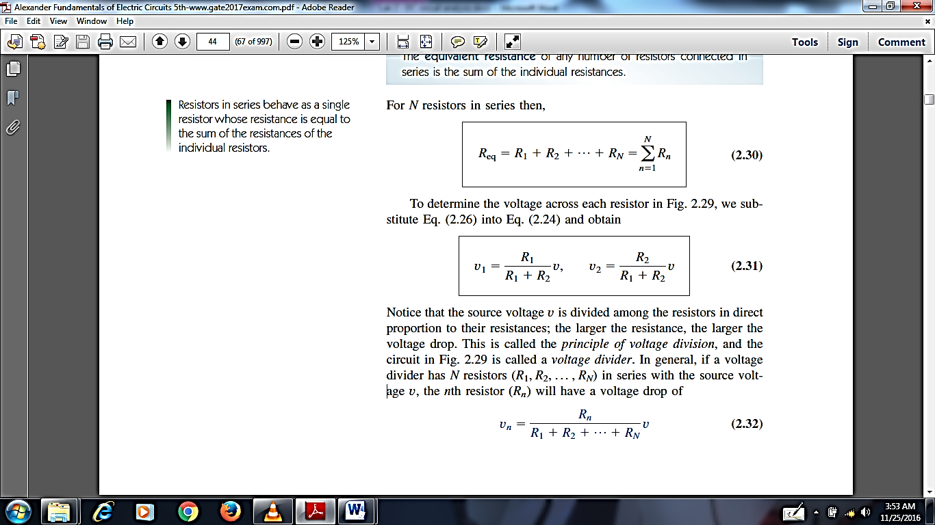

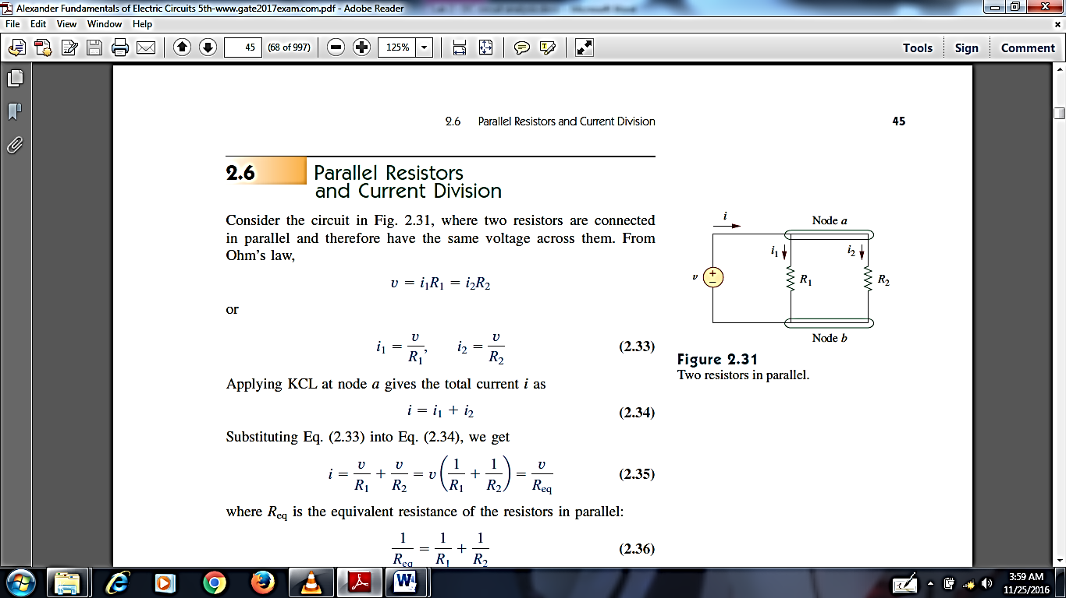

Figure 2: Two resistors in parallel

To find the branch currents we have the following formula:

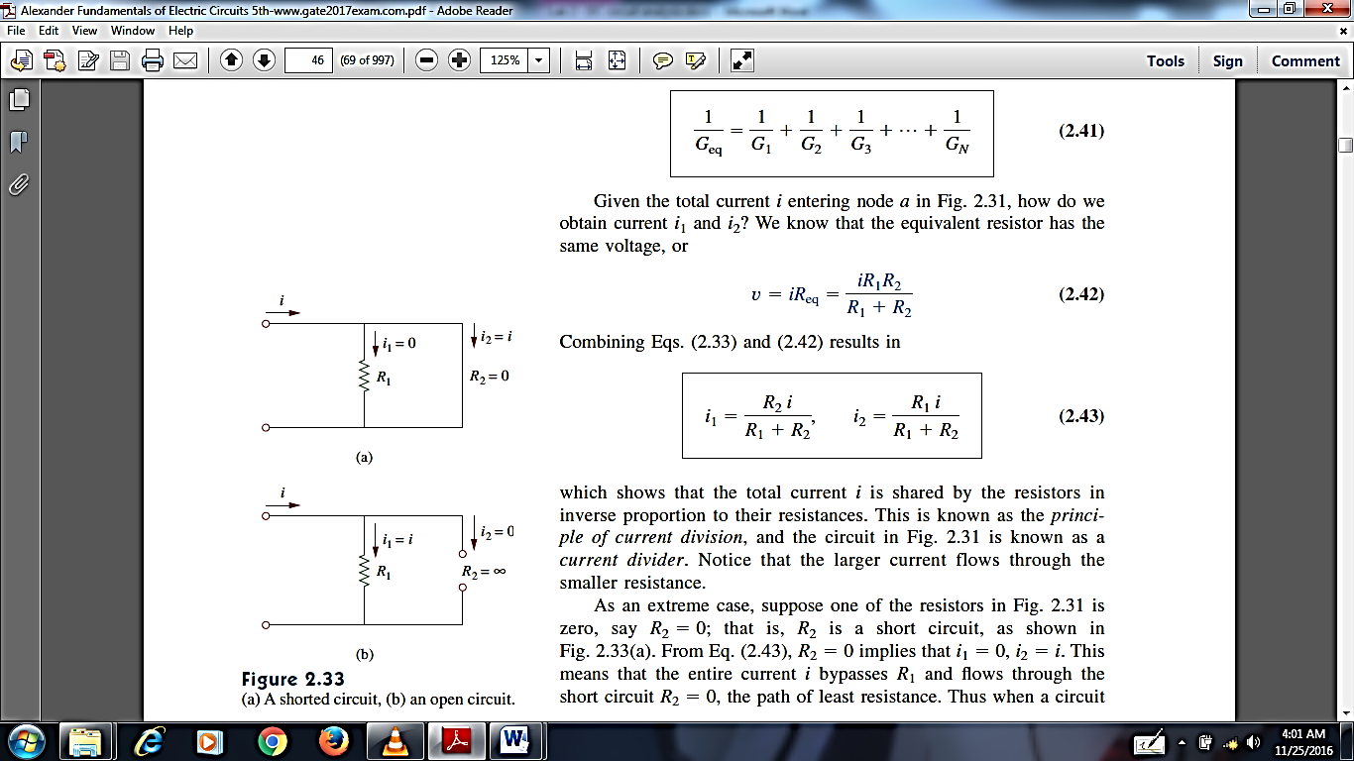

The above two equations show that the total current *i* is shared by the resistors in inverse proportion to their resistances. This is known as the ***principle of current division or current divider rule (CDR)***, and the circuit in figure 2 is known as a ***current divider***. Notice that the larger current flows through the smaller resistance.

**Lab – 2: DC circuit Analysis**

**Objectives:**

* To verify ohms law.
* To practice the two (series and parallel) connection of resistors
* To prove the VDR, CDR, KVL & KCL.

**Apparatus Used:**

* 3 Fixed Resistors of different values
* 1 DC power supply

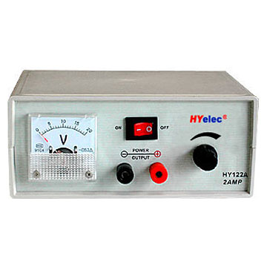Figure 3: DC power source

* Connectors
* 1 Digital Multimeter (DMM)



**Figure 4: Digital Multimeter**

**Procedures**

1. **Series Circuit**
   1. We first received three different resistors and placed them on a good surface.
   2. Then by using a digital Multimeter (DMM) we measured their resistances.
   3. Following the above we adjusted our DC power supply by using a DMM. We place the probes of the DMM on the output of the source and adjusted the supply until we got the reading we wanted which was 12 V.
   4. Then we connected the three resistors in series as shown in figure 5.
   5. Thereafter we calculated the total resistance, total current and individual voltage by using formulas and then we measured the total resistance, total current and individual resistance by using a DMM. To measure the total resistance of a circuit we can simply place the probes of the DMM at the lines where the power supply is connected.
   6. Finally we used VDR (voltage divider rule) to find the individual voltages by using formulas.
2. **Parallel Circuit**
   1. In the beginning we adjusted the DC power supply to 12V.
   2. Thereafter we connected the 3 resistors in parallel as shown in figure 6.
   3. Then we calculated the total resistance, total current, and individual current by using formulas. After this we measured the total resistance, total current and individual current by using a DMM.
   4. Then we applied CDR (current divider rule) and calculate the individual current by using formulas.
3. **Series – Parallel Circuit**
   1. Just like before we adjusted the power supply to 12 V.
   2. We connected the two resistors in parallel first and the third in series with them as shown in figure 7.
   3. Then we calculated the total resistance, total current, individual current and individual voltage by using formulas. Then we measured the above values by using a DMM.
   4. Finally we used CDR to calculate the individual currents and VDR to calculated the individual voltages.

**Result and Discussion**

From the experiments we have done we have obtained the following measurements. The calculated values are obtained by using the formulas expressed for the corresponding concept in the Theoretical Background section of this report.

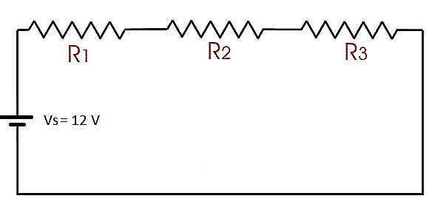

Figure 5: Resistors in series

|  |  |  |  |
| --- | --- | --- | --- |
|  | R1 | R2 | R­3 |
| Measured Value | 332 ($Ω$) | 466 ($Ω$) | 100 () |

|  |  |  |  |  |  |
| --- | --- | --- | --- | --- | --- |
| Resistors in Series | | | | | |
|  | RT() | IT (mA) | V1 (V) | V2(V) | V3(V) |
| Calculated value | 898 | 13.4 | 4.436 | 6.224 | 1.34 |
| Measured value | 898 | 13.3 | 4.43 | 6.23 | 1.34 |

* Here by using VDR we obtained the individual voltages for the 3 resistors. And thus we proved that the summation of these voltages gives the total voltage (Vs).

Vs = V1 + V2 + V3 Vs = 4.436 + 6.224 + 1.34 = 12 V (true)

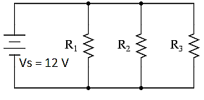

Figure 6: Resistors in parallel

|  |  |  |  |  |  |
| --- | --- | --- | --- | --- | --- |
| Resistors in Parallel | | | | | |
|  | RT() | IT (mA) | I1 (mA) | I2 (mA) | I3 (mA) |
| Calculated value | 65.97 | 182 | 36 | 25.7 | 120 |
| Measured value | 66.3 | 180.1 | 36.3 | 25.9 | 121.5 |

* Here by using CDR we obtained the individual branch currents for the 3 resistors. And thus we proved that the summation of these currents gives the total current (IT).

IT = I1 + I2 + I3 IT = 36 + 25.7 + 120 = 181.7 mA $≅$ 182 mA (true)

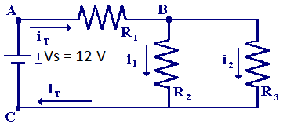

Figure 7: Resistors in series and parallel

|  |  |  |  |  |  |  |  |  |
| --- | --- | --- | --- | --- | --- | --- | --- | --- |
| Resistors in Series and Parallel | | | | | | | | |
|  | RT () | IT (mA) | I1 (mA) | I2 (mA) | I3 (mA) | V1 (V) | V2(V) | V3(V) |
| Calculated value | 414.23 | 29 | 29 | 5.1 | 23.8 | 9.63 | 2.39 | 2.39 |
| Measured value | 414 | 29.3 | 29.3 | 5.2 | 24 | 9.61 | 2.4 | 2.4 |

* Here by using CDR and VDR we obtained the individual branch currents and voltages for the 3 resistors. And thus we proved that the summation of these currents and voltages gives the total current (IT) and the total voltage (Vs) respectively.

IT = I1= I2 + I3 IT = 5.1 + 23.8 = 28.9 mA29 mA (true)

Vs = V1 + (V2= V3)Vs = 9.36 + 2.39 = 12.02 V $≅$ 12 V(true)

**Conclusions and Questions**

1. In what type of connection is that the resistance value is higher (maximum)? How about the current? Which type of connection is better to have higher power?

* We found that the total resistance obtains its highest value in a series Circuit.
* On the other hand the current reaches its peak in a Parallel Circuit.

Power = (Current) x (Voltage)

Let P1 = the power for a series circuit P2 = the power for a parallel circuit

P3 = the power for a series – parallel circuit

P1 = IV = (12) x (0.0134) = **0.161 W** P2 = (12) x (0.182) = **2.18 W**

P3 = (12) x (0.029) = **0.35 W**

* From the above calculations we observed that a parallel circuit is where we can harvest a high power.

**Photos of our Experiments**

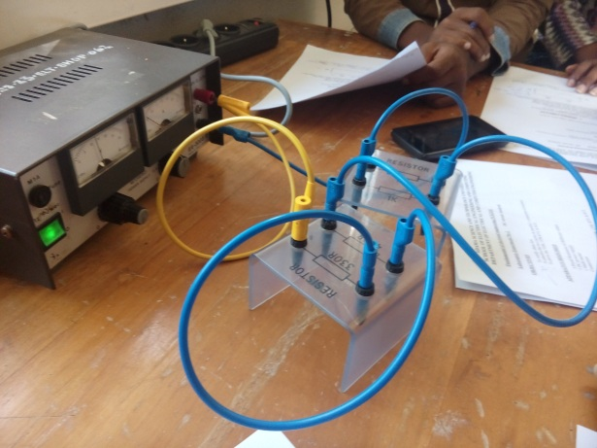

Figure 8: Photo taken during experiment

**References**

* Fundamentals of Electric Circuits, C. K. Alexander and M. N. O. Sadiku

***“We have neither received nor provided any help on the writing of this lab report.”***

*_________________*

**Thank you!**